Lab 5.7 CronJobs

1. Create a cronjob.yml file as shown below:

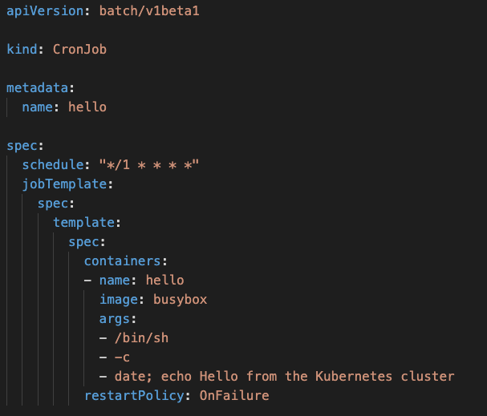

1. Create a CronJob

**kubectl create -f cronjob.yml**

1. Check the completion status of the job

**kubectl get jobs**

1. Have a look at the logs of the Pod

**kubectl logs -f <podName>**

1. Have a look at more details of the Job

**kubectl describe job**